|  |  |
| --- | --- |
| Heritage management document  Lot 1 DP 131409 1316 Yass River Road | Submission to request consideration for building approval under Clause 5.10.10 of Yass Valley Local Environmental Plan 2013  Editor  Prepared by Dr Michelle Hyde |

**Heritage Management Document for Lot 1 DP 131409 1316 Yass River Road Yass**

This report was prepared by Dr Michelle Hyde, BScAgr, PhD. She has previously carried out heritage restorations at a property in Glebe, NSW and Hunters Hill, NSW. Dr Hyde also has experience in agricultural restoration and Indigenous consultation and cultural safety and awareness (a proud Gamilaraay woman). She also has historical family links to the area. The purchaser has the strong desire to restore the historic church and obtain dwelling entitlement to establish a small dwelling integrated to the church in order to preserve and ensure the on-going conservation of the church and cemetery. The purchaser wishes to ensure the survival and preservation of this important locally significant item.

The report also contains material and feedback from Cassandra Lowe, Lowe Design and from Mr John Franklin, Franklin Consulting Australasia PTY LTD trading as Soil and Water, as well as feedback from Mr Rob Corken who holds qualifications in Urban and Regional Planning and has worked in Strategic Planning for over 20 years. Support, advice and suggestions from Mr Pip Giovanelli, Heritage Advisor, Yass Valley Council have been pivotal in submitting this application. Others consulted in the preparation of this report include:

Yass Valley Council

* Frances Henman, Strategic Planning Project Officer
* Liz Makin Strategic, Planning Manager
* John Mannweiler, Development Control Manager
* Mr Ian Dencker, Acting Manager Development Control

Heritage Advisory Services

* Mr Pip Giovanelli, Heritage adviser, Yass Valley Council (as mentioned)
* Yass and District Historical Society
* Wesleyan Methodist Church Australia National Office
* Buru Ngunawal Aboriginal Corporation

Environment NSW

* Mr Roy Barker, Heritage Operations Officer, Department of Premier and Cabinet

Site advice

* Camilla Taylor, Solicitor, Taylor Legal, Yass
* Cassandra Lowe, Lowe Design and Drafting
* John Franklin, Franklin Consulting Australia PTY LTD Soil and Water
* Aunty Lavinus Ingram

This Heritage Management Document addresses the four sides of heritage conservation – evidential, historical, aesthetic and communal.

The property 1316 Yass River Road currently does not have building approval. This document is part of a submission to request consideration for building approval for this property under Clause 5.10.10 of Yass Valley Local Environmental Plan 2013 as below:

(10) Conservation incentives

The consent authority may grant consent to development for any purpose of **a building that is a heritage item or of the land on which such a building is erected**, or for any purpose on an **Aboriginal place of heritage significance**, even though development for that purpose would otherwise not be allowed by this Plan, if the consent authority is satisfied that—

(a) **the conservation of the heritage item or Aboriginal place of heritage significance is facilitated by the granting of consent**, and

(b) **the proposed development is in accordance with a heritage management document that has been approved by the consent authority**, and

(c) **the consent to the proposed development would require that all necessary conservation work identified in the heritage management document is carried out,** and

(d) **the proposed development would not adversely affect the heritage significance of the heritage item, including its setting, or the heritage significance of the Aboriginal place of heritage significance**, and

(e) **the proposed development would not have any significant adverse effect on the amenity of the surrounding area**.

The heritage management document should indicate the **nature of your development**, how your proposed **development respects the heritage significance of the place** **and surrounding area**, and how it **facilitates conservation of the place**. These documents are often prepared by someone with heritage expertise and are usually submitted as part of the development application.

1. **Background *(addressing the evidential side of the Heritage Statement)***

The present owner of the site, Dr Michelle Hyde, purchased the site in December 2020 with the aim of ensuring the on-going conservation of the church and cemetery. The purchase took place after consulting widely with relevant stakeholders such as the Heritage Adviser, Yass Valley Council, Yass Valley Council staff and local Aboriginal custodians and knowledge holders. The purchaser has experience in heritage restoration (property in Glebe NSW and Hunters Hill NSW) as well as agricultural restoration and Indigenous consultation and cultural safety and awareness (a proud Gamilaraay woman). The purchaser also has historical family links to the area. The purchaser has the strong desire to adapt the historic church and obtain dwelling entitlement to establish a small dwelling integrated to the church in order to preserve and ensure the on-going conservation of the church and cemetery. The purchaser wishes to ensure the survival and preservation of this important locally significant item.

Dr Hyde met with Mr Pip Giovanelli, Heritage advisor YVC in November 2020 (and also subsequently in August 2022) for a site inspection and discussion prior to purchase of the property. Mr Giovanelli gave his opinion (Attachment A) that a small addition to the existing church could be done in a manner sympathetic to heritage values and could ensure the ongoing conservation of the church and cemetery.

The site comprises the former Methodist church which is listed on the Yass Valley Schedule as a locally significant item. The building has very high integrity externally and internally. The land portion is approximately 4000 sq m and includes a small cemetery behind the church with a number of well-defined headstones and monuments. At the rear of the land portion is a variety of well-established and mature eucalypt trees and a rich and diverse array of native grasses are present on the site.

Dr Hyde has held regular consultations with Mr Roy Barker, Team Leader Heritage Programs, West, Environment and Heritage, Department of Planning and Environment regarding ongoing protection of ancestors resting on the property. Dr Hyde has also corresponded with Aunty Lavinus Ingram to determine a plan to acknowledge the ancestors and a mounted plaque that tells the story for future generations has been agreed upon (Attachment B). In addition, Dr Hyde plans to develop a reflection and meditation garden to acknowledge the ancestors at rest on Yass River Road. Aunty Lavinus Ingram has agreed to visit the site and assist with planning and developing the acknowledgement.

At present there is no dwelling entitlement. The new owner respects the site’s integrity and is keen to establish a small dwelling integrated with the existing church in a manner sympathetic to heritage values in order to ensure the ongoing conservation of the church and cemetery.

1. **History of the site (settler perspective) *(addressing the historical and communal side of the Heritage Statement)***

The settler history of the site was researched by the purchaser by consulting archives such as Trove, as well as local historians and the Yass and District Historical Society (Attachment C). The current owner has some family connections to the area, including relatives that attended the church when it was used for services.

Some of the very earliest settlers along the Yass River were supporters of the Methodist (or Wesleyan) church. The movement was begun by John Wesley who led a revival movement within the Church of England in the late 1700s. Sobriety, hard work and adherence to Christian values, as well as a strong community focus were basic to this movement. An early sketch map of the river shows small, unregistered holdings of the free immigrants Noah Davies (arrived in NSW in 1838) and William Armstrong (arrived in 1839). These men and their wives and families were important settlers in the district. Noah married Mary Ann Sainsbury and William married Mary Edgerton. Mary and Noah are buried in the cemetery with their graves marked with a simple painted metal strip.

By the 1850s a small bark slab hut with a bark roof was built at Mundoonan. This may not have been on the site of the present church, but further up the river closer to Edgerton. The original trustees seem to have been James Thompson, Obadiah Lewes, Robert Wiggins, Noah Davis all of Mundoonan. It served as a church, school and Sunday school for both children and adults. Mary Ann Davies started religious classes and her husband Noah would often be the preacher. There is a plaque to the memory of Obediah Lewis 40 years a preacher inside the church and James Thompson (along with John, Martha Mary and Hannah Thompson) are buried in the cemetery.

The bark slab hut was destroyed by fire and the church was rebuilt in brick at the present site. A team of neighbours led by the Thompson brothers rebuilt the church. The foundation stone was laid in 1861 and the church was officially opened on March 21, 1863. The date 1862 is still clearly visible above the entrance to the church. Other prominent Yass River families that worshipped at the church included those of Sainsbury, Foot Wiggins Petty, Duffey, Eagen, Cater, Wheatley, Mater, Edgerton, Woodman, Wilkinson, Sleeman, Walmsley and others. Sleeman, Walmsley, Wright and Johnson family members, including children, are buried in the graveyard.

An article from the *Sydney Mail (NSW: 1860 - 1871), Saturday 15 February 1862, page 2*

On Thursday last the foundation stone of a new Wesleyan chapel at Mundoonan was laid by Mr. Thomas Brown, of Jerriwa. The site of the church is on an acre of ground, given for the purpose by Mr. Robert Wiggins, of Sprucemount, and is in close proximity to that gentleman's dwelling. The building will have a stone foundation, the remainder being constructed of brick; it will measure nineteen feet by twenty-nine feet. The contract price for the erection of the chapel is, we believe, about £206, the greater portion of which sum has already been subscribed. The fitting-up of the interior will have to be completed at a cost over that stated. It is expected that the chapel will be ready for occupation within the next three months, A collection for the building fund amounted to £21 odd, — Yass Courier.

The church was closed in 1986. At that time Graeme Challinor recorded the names and locations of those buried at the cemetery (Attachment D).

1. **Aboriginal history and significance of the area *(addressing the historical and communal side of the Heritage Statement)***

Buru Ngunawal Aboriginal Corporation (http://www.buru-ngunawal.com/index.html) provide information on the history of the local Traditional Custodians of the area. The Ngunawal people have occupied the area in the vicinity of the present town of Yass, presumably since the Pleistocene age, and there is sound evidence for a continuous and unbroken association by Aboriginal people with certain places around Yass. During the 19802 the persistence of local Aboriginal families in objecting to various developments prosed by Yass Shire Council triggered a major study (White and Cane, 1986) commissioned by the National Parks and Wildlife Service (Attachment E).

White and Cane (1986) assert that the European contact period can be divided into three broad phases:

1. Following traditional movement patterns (19820s to 1860s)
2. Gradual accommodation with Europeans (1865 to 1885)
3. Enforced movement and eventual dispersion (1885 to 1955)

By the 1850’s – the time of the building of the present church – the time was still ‘early contact’. One of the earliest accounts of Aboriginal people in the district was that of ‘the blacks spearing cattle’ in 1830 (Attachment F) (Bayley, in Whitehouse 1973). The town of Yass was declared in 1838 and was generally avoided by Aboriginal people apart for the annual blanket issue. There were certainly traditional living sites within the township, as evidenced by the objection by 1400 warriors to the destruction of their camping area for construction of the Catholic Church.

Several Aboriginal reserves has been established by 1851 but were not used. By the mid-1860s Aborigines began forming small camps on the outskirts of the town and on the stations of sympathetic landowners. By 1900 the Aboriginal Protection Board was under pressure to move Aboriginal people further away from town, but these efforts failed. In 1909 the Edgerton reserve was established (20km form Yass on the Yass River Road) ad again was a failure, although a number of Aboriginal people are buried in the cemetery and local ties remain. The removal of children from the reserves largely took place between 1090 and 1930. By mid-1944 the Aboriginal Protection Board adopted the assimilation principle, and a number of Aboriginal families were housed in town.

In the mid-1970s local families referred to possible disturbance of burial sites by the proposed Yass bypass. Aboriginal family history and oral history knowledge told of the graves of Aboriginal people along the ridge top (now followed by Yellow Creek Road). A debate which lasted over a decade and caused a lot of acrimony and the eventual departure of Aboriginal families with ties to the area resulted. After extensive archaeological research by White and Cane (1986) a newspaper article was found, describing the burials.

The present owner of the church block was contacted by Mr Roy Barker in March 2021, in his position as Heritage Operations Officer, Community Engagement, Department of Premier and Cabinet, to invite her to discuss Aboriginal ancestors resting on the block. This resulted in communications with Aunty Lavinus Ingram and the development of a plan to erect a memorial inscription and a memorial garden to honour the ancestors and make sure that they are remembered by future generations. Plans are being made to assist Aunty Lavinus to visit the site to give us further information and guidance.

1. **Nature of the development *(addressing the aesthetic side of the Heritage Statement)***

The nature of the development is to establish a small dwelling as an addition to the existing church (detailed plans submitted as part of the Development Application). It is proposed that an entry is cut into the rear wall of the church and a small building comprising of bedroom/bathroom/living area is added, utilising the church as the main kitchen and living area. The addition will be discreetly positioned behind the church. No additional access will be required. No vegetation will be required to removed apart from some grass that will be scraped off building works. The proposed new dwelling is designed to be self-sufficient in terms of water, thermal comfort and energy. It respects the heritage of the church as the visually dominant structure. Traditional building materials will be used throughout. The new dwelling meets community expectations for a rural lifestyle while maintaining the structural and visual integrity of the church building.

The proposed addition to the heritage building is subordinate to the heritage item and juxtaposed against it. The proposed addition uses contemporary materials (Lysaght Enseam – a contemporary cladding material; extensive use of glass; skillion roof) and uses a building design that also reflects historic elements in the design.

The use of contemporary materials while using materials reflective of the historic design provides a clear delineation between the original and additional aspects of the building. This design was guided by advice from Mr Pip Giovanelli, Heritage adviser, Yass Valley Council, during two site visits and related correspondence.

1. **Development respects the heritage significance of the place** **and surrounding area**

As outlined above, the area in general has heritage significance to the local Traditional Custodians, The Ngunawal people, as well as specific significance as a place in which ancestors rest, as detailed by Aunty Lavinus Ingram. This Aboriginal heritage significance will be respected in on ongoing manner by the erection of a monument and garden as detailed in Section 3 and also shown in the site diagram (Attachment F).

The area also has significant settler heritage significance as detailed elsewhere in this document.

1. **Development facilitates conservation of the place (summary)**

Development and restoration of the place will conserve and protect this important local property. Without development the property is likely to degrade until it is no longer able to be restored. The development proposed will not only preserve the Church building but also the graves in the cemetery, as well as memorialising the Aboriginal ancestors resting at the site.

Without building and dwelling approval, the purchaser will not be able to afford to carry out the restoration and conservation. Additionally, having the purchaser living on site will facilitate ongoing conservation of the building and the site.

**Attachments:**

Attachment A: Report from Mr Pip Giovanelli, Heritage Adviser, Yass Valley Council

Attachment B: Email correspondence with Aunty Lavinus Ingram (Aboriginal Elder) and Mr Roy Barker Team Leader Heritage Programs, West, Environment and Heritage, Department of Planning and Environment

Attachment C: Report from the Yass and District Historical Society on history of the church building

Attachment D: Yass River Cemetery (Author: Graeme Challinor)

References

Ian White and Scott Cane (1986) An investigation of Aboriginal Settlements and burial patterns in the vicinity of Yass: a report to the National Parks and Wildlife Service, Queanbeyan. Canberra: ANU Archaeological Consultancies, Anutech PTY LTD, 1986

Russell Whitehurst (1973) W. Bayley’s history of Yass.

Attachment A. Report from Mr Pip Giovanelli, Heritage Adviser, Yass Valley Council

**YASS VALLEY COUNCIL Heritage Advisory Service**

20 November 2020

The General Manager,

Yass Valley Council

PO Box 6, YASS NSW 2582

Attention: Frances Henman

**1316 Yass River Road**

Adaptation of historic church and obtaining dwelling entitlement

The former Methodist church is listed on the Yass Valley heritage schedule as a locally significant item. The building has very high integrity both externally and internally. The listing includes a small cemetery behind the church with a number of well-defined headstones and monuments although the boundary of the collective burials has not been established. At the rear of the land portion is a variety of well-established and mature eucalypt trees, and a rich and diverse array of native grasses cover the site. Mature exotic trees grow between the church and the road and partially block views to the building.

The land portion is approximately 4,000 sq m and at present there is no dwelling entitlement.

The new owner respects the site’s integrity and is keen to establish a small dwelling either adjacent to the church or integrated with it.

Two options were discussed on site. One is to build a new separate dwelling of about 80 sq m to the west of the church on a part of the site that is free of trees and with possibly disturbed topsoil. The other option is to cut an entry into the rear wall of the church and build a small addition for bedroom, (kitchen?) and bathroom, using the church as the main living area.

Both options could be done in a manner sympathetic to heritage values and could ensure the on-going conservation of the church and cemetery.

To obtain dwelling entitlement Council may allow use of YVC LEP 2013 clause 5.10 (10) ***Conservation incentives*** copied below.

*The consent authority may grant consent to development for any purpose of a building that is a heritage item or of the land on which such a building is erected, or for any purpose on an Aboriginal place of heritage significance, even though development for that purpose would otherwise not be allowed by this Plan, if the consent authority is satisfied that—*

*(a) the conservation of the heritage item or Aboriginal place of heritage significance is facilitated by the granting of consent, and*

*(b) the proposed development is in accordance with a heritage management document that has been approved by the consent authority, and*

*(c) the consent to the proposed development would require that all necessary conservation work identified in the heritage management document is carried out, and*

*(d) the proposed development would not adversely affect the heritage significance of the heritage item, including its setting, or the heritage significance of the Aboriginal place of heritage significance, and*

*(e) the proposed development would not have any significant adverse effect on the amenity of the surrounding area.*

In addition to built-heritage issues, there may be other matters to consider including boundary setbacks, remnant vegetation, bush fire, sewerage discharge, potential location of unmarked burials, and access to the monuments for descendants etc.

It is suggested the heritage management document be prepared by a person or organisation that has the appropriate level of expertise to address the historic and natural values on the site.

The owner should discuss with Council’s planning team if the use of the clause is appropriate and what the next steps should be.

In the meantime, minor maintenance to the building, such as repainting or repairing decayed timber using similar materials and colours, or replacing downpipes may be undertaken without referral. Alterations that may change the appearance of the building’s exterior such as replacing the front entry, altering windows, re-roofing or installing rain water tanks should be done using Council’s Minor Works form. There is no charge for Minor Works approval.

Pip Giovanelli

Heritage adviser, YVC

Attachment B: Email correspondence with Aunty Lavinus Ingram (Aboriginal Elder) and Mr Roy Barker Team Leader Heritage Programs, West, Environment and Heritage, Department of Planning and Environment

**From:** Roy Barker <Roy.Barker@environment.nsw.gov.au> **Sent:** Wednesday, 28 April 2021 1:53 PM **To:** Hyde, Michelle <Michelle.Hyde@nhmrc.gov.au> **Subject:** RE: 1316 Yass River Road [SEC=UNOFFICIAL] [SEC=OFFICIAL]

Hi Michelle,

So nice to meet you yesterday and thanks again for your time.

I will now reach out to the Aunties and let them the know you are happy to discuss caring for the ancestors into the future.

I will keep you up to date on any discussions I have with the Aunties.

Regards,

**Roy Barker | Heritage Operations Officer**

Heritage, Community Engagement, Department of Premier and Cabinet

11 Farrer Place, Queanbeyan, NSW | PO Box 733, Queanbeyan 2620

T: 02 6229 7071 M: 0418 395 029 | [Roy.Barker@environment.nsw.gov.au](mailto:Roy.Barker@environment.nsw.gov.au)

**From:** Roy Barker <[Roy.Barker@environment.nsw.gov.au](mailto:Roy.Barker@environment.nsw.gov.au)>   
**Sent:** Monday, 20 February 2023 8:25 AM  
**To:** [lavinusingram@gmail.com](mailto:lavinusingram@gmail.com)  
**Cc:** Hyde, Michelle <[Michelle.Hyde@nhmrc.gov.au](mailto:Michelle.Hyde@nhmrc.gov.au)>  
**Subject:** E-introduction: Yass River Road

|  |  |  |
| --- | --- | --- |
|  | You don't often get email from [roy.barker@environment.nsw.gov.au](mailto:roy.barker@environment.nsw.gov.au). [Learn why this is important](https://aka.ms/LearnAboutSenderIdentification) |  |

Good morning Aunty Lavinus,

Let me E-introduce you to Michelle Hyde who is the current owner and caretaker of 1316 Yass River Road where the church and burial ground exist.

I think we all agree there needs to be an acknowledgement of the ancestors laying to rest with the church ground by way of a mounted plaque that tells the story for future generations.

Aunty Lavinus and Michell please get in touch with one another to work out a plan to acknowledge the ancestors who are in their resting place on Yass River Road.

Bidjura thuringah (nice day)

**Roy Barker | Team Leader Heritage Programs, West**

Environment and Heritage

**Department of Planning and Environment**

11 Farrer Place, Queanbeyan, NSW | PO Box 733, Queanbeyan 2620

T: 02 6229 7071 M: 0418 395 029 | [roy.barker@environment.nsw.gov.au](mailto:roy.barker@environment.nsw.gov.au)

I’m currently working Monday, Tuesday, Wednesday for urgent enquiries please contact Harvey Johnston on 0407 214 227

Attachment C: Report from the Yass and District Historical Society on history of the church building

THE WESLEYANS OF THE YASS RIVER

The Methodist or Wesleyan church was begun by John Wesley who led a revival movement within the Church of England in England in the later 1700. Sobriety, hard work and adherence to Christian values were basic to this movement. It would seem it was also a recipe for pioneering success. In a colony known for its grog shops, bushrangers and unrelenting hardships of subsistence living in drought, flood and isolation Methodism provided both hope and consolation as well as a common community focus.

Some of the very earliest settlers along the Yass river became ardent supporters of the movement and seem to have formed their own strong community groups both there and at Nanima. An early1847 sketch map of the river shows small unregistered holdings of Noah Davies who arrived in New South Wales in 1838 and William Armstrong in 1839 –both free immigrants. The families of Noah and his wife Mary Ann (Sainsbury) and William and his wife Mary (Edgerton) were to go on to play a significant part in the Wesleyan revival movement that swept through the district from the 1850s.

By the 1850s a small slab church with a bark roof was built at Mundoonan. This may have been the building referred to as the old Mundoonan Church higher up the river nearer to Edgerton’s than the present one. The original trustees seem to have been James Thompson, Obadiah Lewes, Robert Wiggins, Noah Davis all of Mundoonan. It served as a church, school and Sunday school for both children and adults. Mary Ann Davies started religious classes and her husband Noah would often be the preacher.

This primitive building was destroyed by fire. A team of neighbours led by the Thompson brothers John and James who had settled nearby at Greenfields in the 1850s rebuilt the church but this time in brick at a cost of £405. The foundation stone was laid on 6th February 1861 and was officially opened by the Rev. Gaud of Yass on 21st March 1863. The date1862 is still visible above the entrance to this substantial little church. James’s great grandson Bert Thompson recalled the names of other Yass river families; Sainsbury, Foot Wiggins Petty, Duffey, Eagen, Carter, Wheatley, Mater, Edgerton, Woodman and Wilkinson would have worshipped here. Then came the Grubers, Sleemans, Walmsleys, Armours, Johnsons, Wrights, Greys and many more. All these names resonate down the years to the present day although the church closed in 1986.

An article from the *Sydney Mail (NSW: 1860 - 1871), Saturday 15 February 1862, page 2*

 On Thursday last the foundation stone of a new Wesleyan chapel at Mundoonan was laid by Mr. Thomas Brown, of Jerriwa. The site of the church is on an acre of ground, given for the purpose by Mr. Robert Wiggins, of Sprucemount, and is in close proximity to that gentleman's dwelling. The building will have a stone foundation, the remainder being constructed of brick; it will measure nineteen feet by twenty-nine feet. The contract price for the erection of the chapel is, we believe, about £206, the greater portion of which sum has already been subscribed. The fitting-up of the interior will have to be completed at a cost over that stated. It is expected that the chapel will be ready for occupation within the next three months, A collection for the building fund amounted to £21 odd, — Yass Courier.

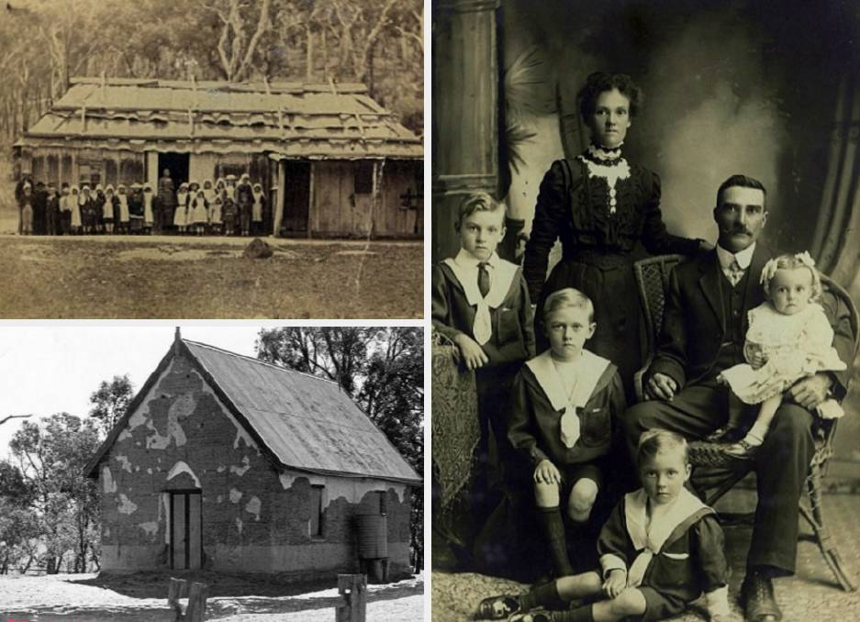

*Original slab, bark roofed Mundoonan Church with Noah Davis and Sunday School*

(Images courtesy of Kerry Thompson)

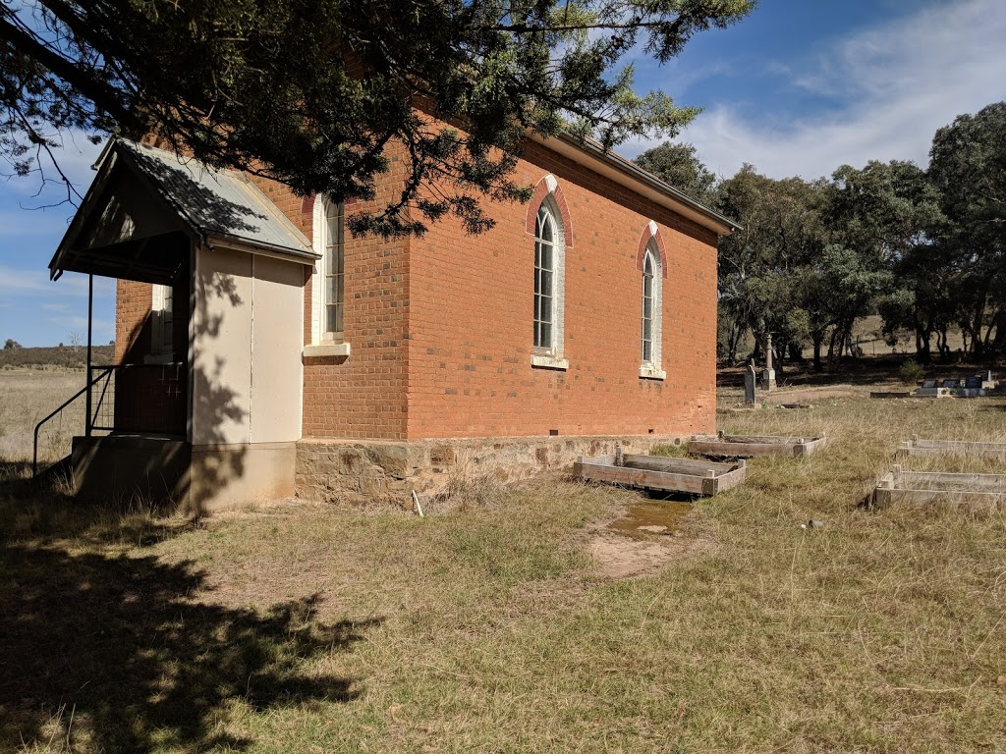

*Mundoonan Wesleyan Chapel still standing 2020*

Attachment D: Yass River Cemetery (Author: Graeme Challinor)

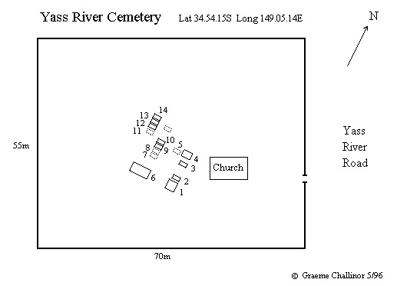

THE CEMETERY ADJOINING MUNDOONAN METHODIST CHURCH ON THE YASS RIVER ROAD, NEW SOUTH WALES. Lat 34.54.15S Long 149.05.15E About 20km north-west of Gundaroo. The numbers refer those in the cemetery diagram.

[Plaque inside the Church] To the memory of Obadiah Lewis, died at Yass on 6.6.1902, aged 82. 40 years a preacher.

1 [column] [south side] In loving memory of Elizabeth Pawley beloved mother of Catherine Sleeman, born Penzance England died 17th February 1900 aged 88 years. 'At Rest' [east side] Catherine Sleeman born Cornwall England died Randwick, New South Wales 14 September 1927, aged 70 years. 'God's greatest gift, remembrance.' [north side] In loving memory of Samuel, beloved husband of Catherine Sleeman born Tavistock England died 2nd October 1920, aged 66 years. 'Forever with the Lord.'

2 In loving memory of Samuel C. Sleeman born Salt Lake City, USA, 20th July 1884 died 12th September 1942. 'At Rest.' [brass plaque] In loving memory of Lena Louisa Victoria Sleeman born 24.5.1887 died 19.1.1947

3 In loving memory of Charlotte wife of Norman Walmsley died Feb 14th 1903 aged 27 years. 'Blessed are the dead that die in the Lord.' [memorial by] Dickson

4 [painted metal strip] Mary Davies died 1891, Noah Davies died 1884

5 [no memorial]

6 [column] [east side] Erected to the memory of John Thompson who died Feby 24th 1892 aged 64 years. 'Swiftly beyond our measure Life's little day speeds on A moment's fleeting pleasure And life and light are gone. Oh thou who in human fashion, Didst render up thy breath, And by the bitter passion Destroy the sting of death. When life's brief day is over, Its toil and care and sin Open thine arms of mercy, And take the weary in.' [south side] Also in memory of Martha Thompson who died Feby 20th 1878 aged 17 years also of Hannah the beloved wife of John Thompson who died March 1st 1881 aged 54 years. 'They rest from their labours.' [west side] Also in memory of James Thompson who died July 1st 1935 aged 76 years. also of Mary the beloved wife of James Thompson who died Novr 23rd 1941 aged 80 years.

7 [no memorial]

8 [no memorial]

9 In loving memory of our dear father William Davis Wright died 25th Sep. 1934 aged 83 years.

10 In loving memory of Geraldine Archbold died 15th Jan. 1922 aged 89 years Erected by her friends.

11 [no memorial]

12 In loving memory of a dear wife and mother Rose Waldermere Johnson born Ipswich 21.12.1908 died Yass 13.8.1965 A loved nana

13 In loving memory of our dear father George Murray Johnson born Gunning 1902 died Yass 14.8.1988 'Devoted life service to Pastoral Industry Always remembered by loving families'

14 In loving memory of a dear wife and nana Hilda Johnson (Sister McAlpine) born Braidwood 1912 - died Yass 1978 'A life dedicated to cristianity [sic] & caring for others. She will long be remembered.'

There are also the unmarked graves of (a) Baby Armstrong died 16.1.1881 (b) Amelia Jane Armstrong died 13.3.1889 both children of John and Amelia Jane Armstrong (c) Mary Jane Bennett born 1.1.1843, died 30.9.1864 at Big Hill aged 21 yrs and 9 mo. Buried Mundoonan 3 Oct 1864

© Graeme Challinor May 1996 ------------